**Healthcare Insights**

This dataset contains information about patients admitted to a hospital, including demographic details, medical conditions, treatments, and Insurance provider. The dataset comprises the following columns:

* **Medical Condition**: Description of the medical condition or diagnosis for which the patient is admitted.
* **Date of Admission**: Date when the patient was admitted to the hospital.
* **Gender**: Gender of the patients (e.g., male, female).
* **Insurance Provider**: Name of the insurance provider covering the patient's medical expenses.
* **Admission Type**: Type of admission, such as emergency, elective, or transfer.
* **Discharge Date**: Date when the patient was discharged from the hospital.
* **Medication**: List of medications prescribed to the patient during their hospitalization.

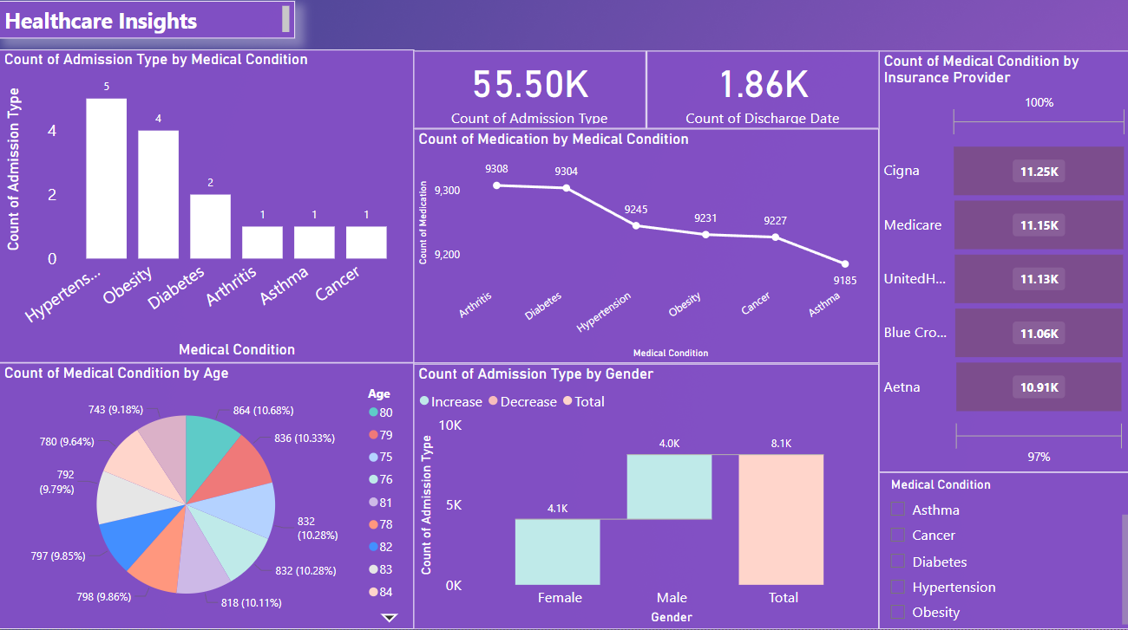

Findings

1. Top Three Most Common Medical Conditions:

Arthritis -9308

Diabetes – 9304

Hypertension-9245

1. **Male and female patients**

**Male-4032**

**Female- 4099**

**Total – 8131**

1. **TOP 10 oldest** patient and their medical condition.
2. There are 39876 unique hospitals included in the dataset.
3. Name of the insurance provider covering the patient's medical expenses.